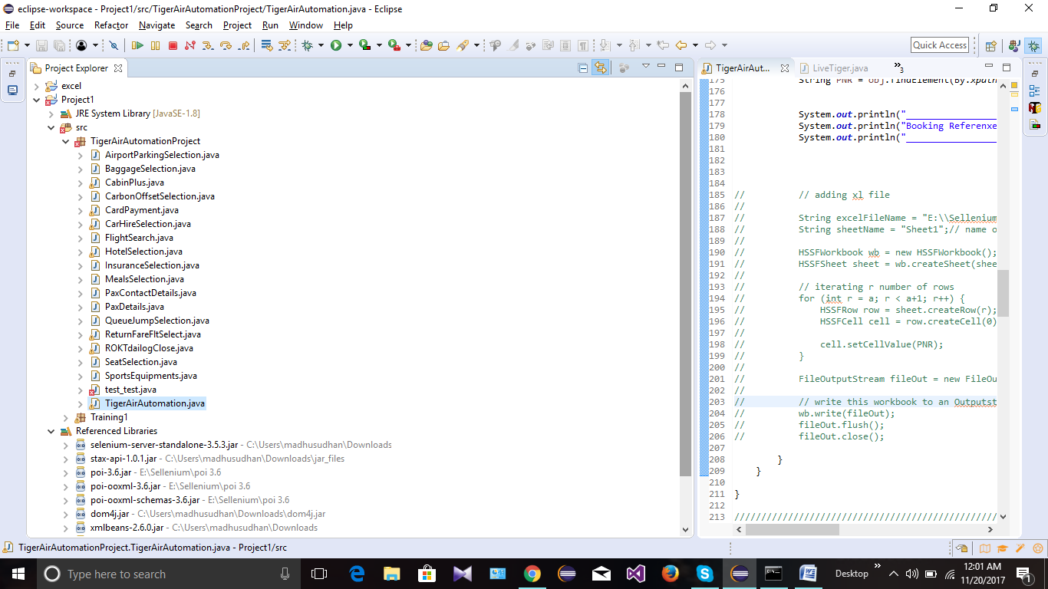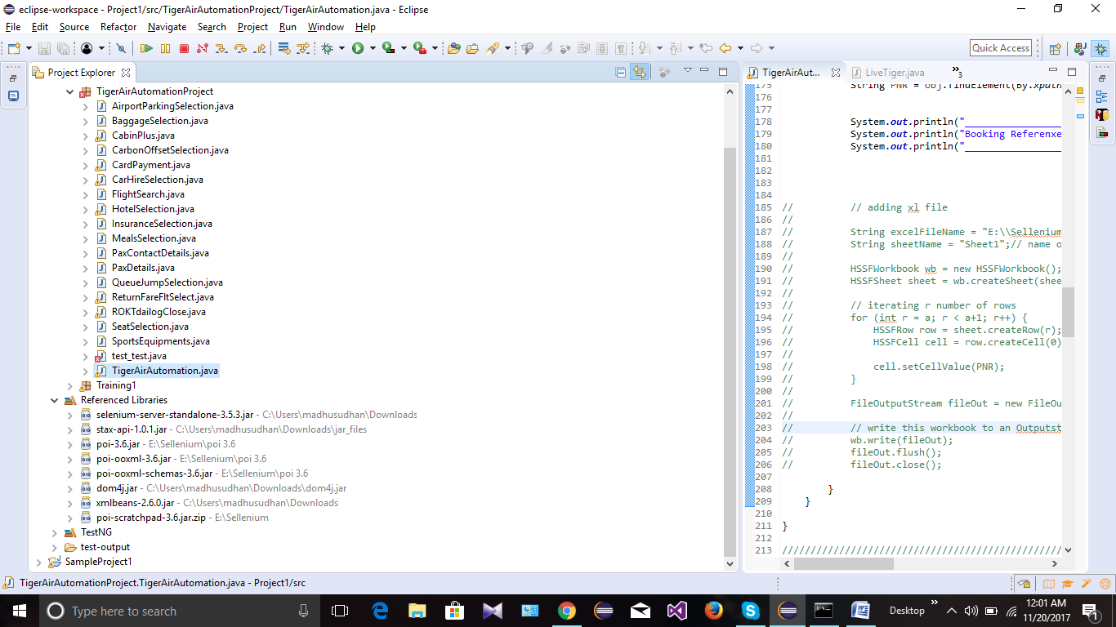

package TigerAirAutomationProject;

import java.io.File;

import java.io.FileInputStream;

import java.io.FileNotFoundException;

import java.io.FileOutputStream;

import java.io.IOException;

import java.util.HashMap;

import java.util.Iterator;

import java.util.List;

import java.util.Set;

import java.util.regex.Pattern;

import org.apache.poi.hssf.usermodel.HSSFCell;

import org.apache.poi.hssf.usermodel.HSSFRow;

import org.apache.poi.hssf.usermodel.HSSFSheet;

import org.apache.poi.hssf.usermodel.HSSFWorkbook;

import org.apache.poi.xssf.usermodel.XSSFSheet;

import org.apache.poi.xssf.usermodel.XSSFWorkbook;

import org.omg.CORBA.OBJ_ADAPTER;

import org.openqa.selenium.Alert;

import org.openqa.selenium.By;

import org.openqa.selenium.Dimension;

import org.openqa.selenium.JavascriptExecutor;

import org.openqa.selenium.Keys;

import org.openqa.selenium.WebDriver;

import org.openqa.selenium.WebElement;

import org.openqa.selenium.chrome.ChromeDriver;

import org.openqa.selenium.firefox.FirefoxDriver;

import org.openqa.selenium.support.ui.Select;

public class TigerAirAutomation

{

static WebDriver obj;

public TigerAirAutomation(WebDriver obj) {

}

public static void main(String[] args) throws Exception {

// TODO Auto-generated method stub

for (int a = 0; a < 3; a++) {

String filePath = "E:\\Sellenium\\FrameWork\\TestData\\BookingDetails.xlsx";

FileInputStream file = new FileInputStream(new File(filePath));

XSSFWorkbook wrkBook = new XSSFWorkbook(file);

XSSFSheet wrkSht = wrkBook.getSheetAt(a);

HashMap<String, String> map = new HashMap<String, String>();

for (int i = 1; i < 24; i++) {

map.put(wrkSht.getRow(i).getCell(0).getStringCellValue(),

wrkSht.getRow(i).getCell(1).getStringCellValue());

}

System.setProperty("webdriver.gecko.driver", "C:\\Users\\madhusudhan\\Desktop\\geckodriver.exe");

WebDriver obj = new FirefoxDriver();

obj.get("https://uatbooking.tigerair.com.au/TigerAirIBE3415/Booking/search");

// Flight Search

FlightSearch fSearch = new FlightSearch();

fSearch.fltSearch(obj, map);

// Flight selection

String fare = "light";

String rtnFareVal = map.get("fareType");

ReturnFareFltSelect rtnLtFr = new ReturnFareFltSelect();

Thread.sleep(3000);

if (rtnFareVal.equals(fare)) {

rtnLtFr.RtnLtFr(obj);

} else {

rtnLtFr.RtnExpFr(obj);

}

Thread.sleep(3000);

// Enter Pax Details

PaxDetails paxDet1 = new PaxDetails();

paxDet1.PasngrDet1(obj, map);

// // insert test case validation-- If required at any point of application

// flow.

// String PaxName = obj.findElement(By.id("passengerSelet")).getText();

// System.out.println("Pax Name is :"+PaxName);

// Pax Contact details

PaxContactDetails PaxCntDet = new PaxContactDetails();

PaxCntDet.PaxCntDetails(obj, map);

// Cabin+ Selection

CabinPlus cabinSelect = new CabinPlus();

cabinSelect.rtnCabinPls(obj);

// Baggage Selection

BaggageSelection SlctBag = new BaggageSelection();

SlctBag.rtnSelectBaggage(obj);

// SPorts Equipment

SportsEquipments SprtsEquip = new SportsEquipments();

SprtsEquip.OnePieceSportsEquip(obj);

// Navigate to Seat Selection page

obj.findElement(By.id("ContinueBtn")).click();

// Seat Selection

SeatSelection SelectSeat = new SeatSelection();

SelectSeat.noSeatSelection(obj);

Thread.sleep(9000);

// // Select Meal

// MealsSelection SelectMeal = new MealsSelection();

// SelectMeal.rtnMealsSelect(obj);

// Thread.sleep(2000);

//

//

//

// // Select Queue JUmp

// QueueJumpSelection SelectQjmp = new QueueJumpSelection();

// SelectQjmp.rtnQueueJumpSelect(obj);

// Thread.sleep(2000);

//

//

//

// //Select Carbon Offset

// CarbonOffsetSelection SelectCarbonOffset = new CarbonOffsetSelection();

// SelectCarbonOffset.rtnCarbonOffsetSelection(obj);

// Thread.sleep(2000);

//

//

//

// //Select CarHire

// CarHireSelection SelectCarHire = new CarHireSelection();

// SelectCarHire.mSelectCarHire(obj);

// Thread.sleep(2000);

// //Select Hotels

// HotelSelection SelectHotel = new HotelSelection();

// SelectHotel.mHotelSelection(obj);

// Thread.sleep(2000);

// //Select Airport Parking

// AirportParkingSelection SelectAirPortPaking = new AirportParkingSelection();

// SelectAirPortPaking.mairportParkingSelect(obj);

// Thread.sleep(2000);

// Select Insurance

InsuranceSelection SelectInsure = new InsuranceSelection();

SelectInsure.yesInsurance(obj);

Thread.sleep(2000);

// Navigate to Checkout page

obj.findElement(By.id("ContinueBtn")).click();

Thread.sleep(2000);

// Card FOP

CardPayment visaCC = new CardPayment();

visaCC.cardPay(obj, map);

// #disclaimer-check

obj.findElement(By.xpath("//*[@class='check']")).click();

obj.findElement(By.xpath("//*[@class='check']")).click();

obj.findElement(By.id("SubmitPaymentBtn")).click();

Thread.sleep(20000);

obj.navigate().refresh();

String PNR = obj.findElement(By.xpath("//*[@id=\"PNRNumber\"]/h2")).getText();

System.out.println("______________________________________________________________");

System.out.println("Booking Referenxe is"+PNR);

System.out.println("______________________________________________________________");

// // adding xl file

//

// String excelFileName = "E:\\Sellenium\\Test.xls";// name of excel file

// String sheetName = "Sheet1";// name of sheet

//

// HSSFWorkbook wb = new HSSFWorkbook();

// HSSFSheet sheet = wb.createSheet(sheetName);

//

// // iterating r number of rows

// for (int r = a; r < a+1; r++) {

// HSSFRow row = sheet.createRow(r);

// HSSFCell cell = row.createCell(0);

//

// cell.setCellValue(PNR);

// }

//

// FileOutputStream fileOut = new FileOutputStream(excelFileName);

//

// // write this workbook to an Outputstream.

// wb.write(fileOut);

// fileOut.flush();

// fileOut.close();

}

}

}

////////////////////////////////////////////////////////////////////////////////////////////////////////////////////////////

// obj.findElement(By.xpath("//*[@id=\"ux_widget_inner\"]/div[1]/div/div/a")).click();

// obj.switchTo().frame("frame").close();

// obj.findElement(By.xpath("//*[@id=\"ux_widget_inner\"]/div[1]/div/div/a")).click();

// obj.findElement(By.id("rl__roktAppsBanner213659633")).click();

// obj = (FirefoxDriver) obj.switchTo().frame(null);

// obj.findElement(By.xpath("//div[3]/div/div/div[1]/div/div/a")).click();

// String parent = obj.getWindowHandle();

// obj.switchTo().window(parent);

// //obj.close();

// obj.findElement(By.xpath("//*[@id=\"ux_widget_inner\"]/div[1]/div/div/a")).click();

//

// obj.switchTo().alert().dismiss();

//

// String parent = obj.getWindowHandle();

//

// Set<String> children = obj.getWindowHandles();

//

// String windowHandler = null;

//

// Iterator<String> itr = children.iterator();

//

// while(itr.hasNext ())

// {

//

// windowHandler = itr.next();

//

// if(!windowHandler.equals(parent))

// //if(!windowHandle.equals(parent))

// {

//

// obj.switchTo().window(windowHandler);

// Thread.sleep(1000);

//

// obj.close();

//

// }

//

// }

// Thread.sleep(2000);

// ROKTdailogClose roktmsg = new ROKTdailogClose();

// roktmsg.roktDailogClosing(obj);

//

// obj.findElement(By.id("ux_iagree_button")).click();

// obj.findElement(By.id("ux_smartsignup_layout_buttons_next")).click();

// Alert alrt = obj.switchTo().alert();

//

// alrt.dismiss();

// String frameID = "//*[@id=\"rl__widget";

// String regExp = "\\d{9}";

//

// Pattern p = Pattern (frameID + regExp);

// WebElement xPathUserList;

// xPathUserList.findElement(By.xpath(p));

// int size = obj.findElements(By.tagName("iframe")).size();

// System.out.println(size);

//

// Thread.sleep(5000);

// WebElement

// frame=obj.findElement(By.xpath("//iframe[contains(@class='wdHolder.*')]"));

// WebElement

// frame=obj.findElement(By.xpath("//iframe[contains(@id='rl__widget.*')]"));

// Thread.sleep(2000);

// obj.switchTo().frame(frame);

// Thread.sleep(2000);

// WebElement modal =

// obj.findElement(By.xpath("//div[contains(@class,'wdHolder')]"));

// WebElement radio =

// modal.findElement(By.xpath("//iframe[contains(@id='rl__widget.*')]"));

//

//

// obj.switchTo().frame(radio);

// obj.switchTo().parentFrame();

// obj.switchTo().frame(p);

// rl__widget212879716

// rl__widget511487027

// System.out.println("1");

//

// Thread.sleep(3000);

// obj.findElement(By.xpath("(//*[@class='ui_widget_close_button button close

// small'])[1]")).click();

//

// System.out.println("2");

//

// Thread.sleep(2000);

//

// obj.navigate().refresh();

//

//

// String PNR =

// obj.findElement(By.xpath("//*[@id=\"PNRNumber\"]/h2")).getText();

//

// System.out.println(PNR);

//

//

//

// map.put("PNRnumber",PNR);

// Label PNRdetail =new Label(22,2,PNR);

// wrkSht.addCell(PNRdetail);

//

//// adding xl file

//

// String excelFileName = "E:\\Sellenium\\Test.xls";//name of excel file

//

// String sheetName = "Sheet1";//name of sheet

//

// HSSFWorkbook wb = new HSSFWorkbook();

// HSSFSheet sheet = wb.createSheet(sheetName) ;

//

//// iterating r number of rows

// for (int r=1;r < 5; r++ )

// {

// HSSFRow row = sheet.createRow(r);

// HSSFCell cell = row.createCell(0);

//

// cell.setCellValue("Cell "+r+" "+r);

//

// //iterating c number of columns

//// for (int c=0;c < r; c++ )

//// {

//// HSSFCell cell = row.createCell(c);

////

//// cell.setCellValue("Cell "+r+" "+c);

//// }

// }

//

// FileOutputStream fileOut = new FileOutputStream(excelFileName);

//

//// write this workbook to an Outputstream.

// wb.write(fileOut);

// fileOut.flush();

// fileOut.close();

//

// }

// }